Gc (): -

Drawing

int arr[] =new int[3];

int arr2[]= new int[5];

arr2=arr;

arr=null;

example C/C++: -

int main ()

{

int a, I;

a=i++ + ++I;

printf(“%d…..%d”,a, i);

return 0;

}

Gc work force fully

Example: -

Drawing

In java Garbej means difference objects.

Garbej collection is a location. In other word it automatically destroyed unuse object.

An object can be difference in two way.

1. By nullifies objects.

Example 1: - Demo d=new Demo();

d=Null;

1. By difference object

Example 1: -

Demo d=new Demo();

Demo d1=new Demo over;

d1=d;

JVM only destroyed those objects created using new keyword.

If we have created any object without new, we have use finally method for cleanup process.

This method invokes each time before the object garbage collection.

This method is use for destroyed object we not created new keyword.

Garbage collection method use to invoked garbage collection for cleanup process. But it doesn’t granites that it will clean the object.

It only request JVM for cleanup process.

Example: -

**Q. What is garbage collection and finalize method**.

Or How to work Garbage Collection?

**Garbage Collection** is process of reclaiming the runtime unused memory automatically. In other words, it is a way to destroy the unused objects.

Or Garbage collection is the automatic process of eliminating unnecessary object form memory.

Example 1: - Demo d=new Demo();

d=Null;

Example 2: -

Demo d=new Demo ();

Demo d1=new Demo over;

d1=d;

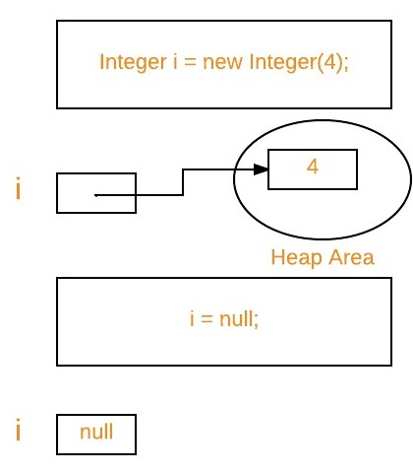

Note: The Garbage collector of JVM collects only those objects that are created by new keyword. So, if you have created any object without new, you can use finalize method to perform cleanup processing (destroying remaining objects).

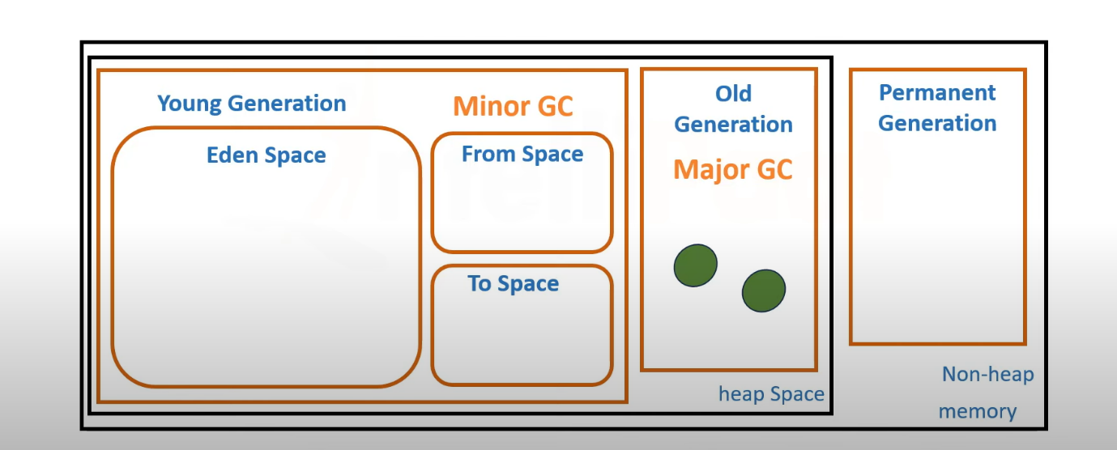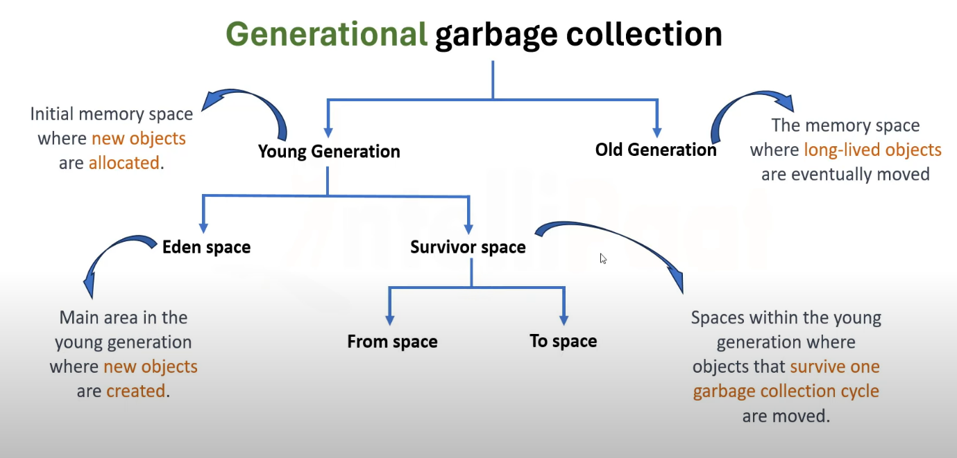

**Types of garbage collector**

Serial garbage collector

Parallel garbage collector

CMS garbage collector

Garbage First(G1) Garbage Collection